COMMON TO DEPARTMENTS OF
BT, CSE, CV, ECE, EEE, ETE.ISE, ME

Date | 22/7/24 | Maximum Marks | 50
Course Code | MIM431T | Duration | 90 Min
Sem | II Semester MTech | CIE – I
RESEARCH METHODOLOGY
Note: Answer all the Questions.

Sl. No. | Questions | M | BT | CO
1 | Illustrate the thinking processes in creative approach of Problem solving. Elucidate the four stages of creative process. Demonstrate creative problem solving with an example  Logical thinking ,Vertical thinking, Critical thinking, Analytical thinking Strategic thinking, Lateral thinking, Outcome thinking, Creative thinking Divergent thinking, Heuristic thinking  four stages of creative process  Preparation, Incubation, Illumination, Verification  Example | 10  4  3  3 | 1 | 1
2 | Explain the characteristics of good hypothesis, and its process of generation with a flowchart. Provide examples of research hypotheses in different fields  characteristics of good hypothesis and its explanation  - A hypothesis must be conceptually clear, meaningful, communicable, grounded in previous knowledge, and commonly acceptable by research workers in the field.  - A hypothesis should be empirically based. If it is theoretically derived or obtained from value judgment, the researcher should seek measurable facts in the phenomenon relating to the problem, in order that it may be worded properly  - A hypothesis must be specific in order to facilitate its testing. The specificity can be evaluated by seeking whether it can be tested quantitatively using operational definitions.  - It is desirable that the hypotheses are formulated so that the existing testing techniques can be used  - Hypotheses unconnected with theory are not desirable since relationships are tested in hypotheses. A precedence is always desirable, except possibly in a totally unexplored research territory.  Process of Hypothesis generation and discussion  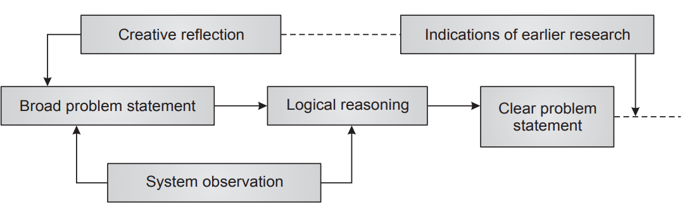  examples of research hypotheses in different fields | 10  5  3  2 | 2 | 1
3 | Discuss the significance of literature review in problem identification by throwing light on its broad aspects.  Significance of literature survey  Literature review has four broad aspects: (i) choice of literature, (ii) search for location/ source of literature, (iii) study of literature, and (iv) organisation of literature. | 10  2  8 | 1 | 1
4 | Bring out the design and study phenomenon in designs with examples.  Design discussion with examples  Design 1—Interrupted time series design, Design 2—Regression discontinuity design, Design 3—Pre-test and post-test non-equivalent design  Conditions - Quasi experimentation | 10  7  3 | 2 | 2
5 | The following data represents the number of units of tablets production (in thousands) per day by five different technicians, by using four different type of technicians. Construct the ANOVA table by shifting the origin to 50 and obtain the F ratio.  Correction factor =20  Between the columns(SSC)=338.8  Between the rows(SSR)=158  Total(SST)=564  Residual error(SSE)=67.2  From table( 5% ), the following are the F values  F(12,3)=3.49  F(12,4)=3.26  Conclusion | 10  2  4  2  1  1 | 3 | 2
  Machines/  Technicians | A | B | C | D | Total
  P | 4 | -2 | 7 | -4 | 5
  Q | 6 | 0 | 12 | 3 | 21
  R | -6 | -4 | 4 | -8 | -14
  S | 3 | -2 | 6 | -6 | 1
  T | -2 | 2 | 9 | -2 | 7
   | 5 | -6 | 38 | -17 | 20
  Source of Variation | Sum of Squares | Degree of freedom | Mean sum of squares | F ratio
  Between the columns | SSC=338.8 | 4-1=3 | 338.8/3=112.9 | 112.9/5.6=20.1
  Between the rows | SSR=158 | 5-1=4 | 158/4=39.5 | 39.5/5.6=7.05
  Residual Error | SSE=67.2 | (4-1)(5-1)=12 | 67.2/12=5.6
   | SST=564

BT-Blooms Taxonomy, CO-Course Outcomes, M-Marks
Marks Distribution | Particulars |  | CO1 | CO2 | CO3 | CO4 | L1 | L2 | L3 | L4 | L5 | L6
Marks Distribution | Quiz | Max Marks | 6 | 4 | - | - | 7 | 3 |  | - | - | -
Marks Distribution | Test | Max Marks | 30 | 20 | - | - | 20 | 20 | 10 | - | - | -

COMMON TO DEPARTMENTS OF
BT, CSE, CV, ECE, EEE, ETE.ISE, ME

Date | 22/7/2024 | Maximum Marks | 10
Course Code | MIM431T | Duration | 20 Min
Sem | II Semester MTech | Quiz – I
RESEARCH METHODOLOGY
Note: Answer all the Questions.

Sno | Question | Marks | BT | CO
1 | In ___________ multivariate experimental designs in which interaction effects among variables is assumed to be negligible.  Latin square design | 1 | 1 | 1
2 | A research intends to explore the result of possible factors for the organization of effective mid-day meal interventions. Then _____________________ research method will be most appropriate for this study.  Ex-post facto method | 1 | 2 | 2
3 | Name the classification of problem which is determined according to some scale on which the whole problem solving process may be rated.  Tame and wicked problems | 1 | 1 | 1
4 | Attitudes, reactions, and opinions of various parties (individual and organisational units) are involved in the _____________ type of problem solving method.  Soft system approach | 1 | 1 | 2
5 | State One of the major advantages of a time series design over other forms of quasi-experimental design  One can assess the maturational trend prior to intervention | 1 | 1 | 1
6 | Identify the one of the essential characteristics of morphological analysis  Decomposition | 1 | 1 | 1
7 | State the two techniques presented to illustrate the logical procedures  Morphological analysis and potential problem analysis | 2 | 1 | 1
8 | Suppose an educational institution wants to forecast the future demand for online courses in the next ten years. Suggest the appropriate method for solving the above situation.  Delphi method | 2 | 2 | 2

